QUESTION 2

AIM:
To create a table named `FACULTY` with columns `FacNo`, `FacName`, `Gender`, `DOB`, `DOJ`, and `MobileNo` using DDL statement.

PROCEDURE:
1. Open the SQL database terminal/client.
2. Execute the `CREATE TABLE` command specifying table name `FACULTY` and defined data types for each attribute.
3. Verify the creation using `DESC FACULTY;`.

CODE / SQL QUERY:

CREATE TABLE FACULTY (
FacNo VARCHAR(4),
FacName VARCHAR(15),
Gender CHAR(1),
DOB DATE,
DOJ DATE,
MobileNo NUMBER(10)
);

Output:
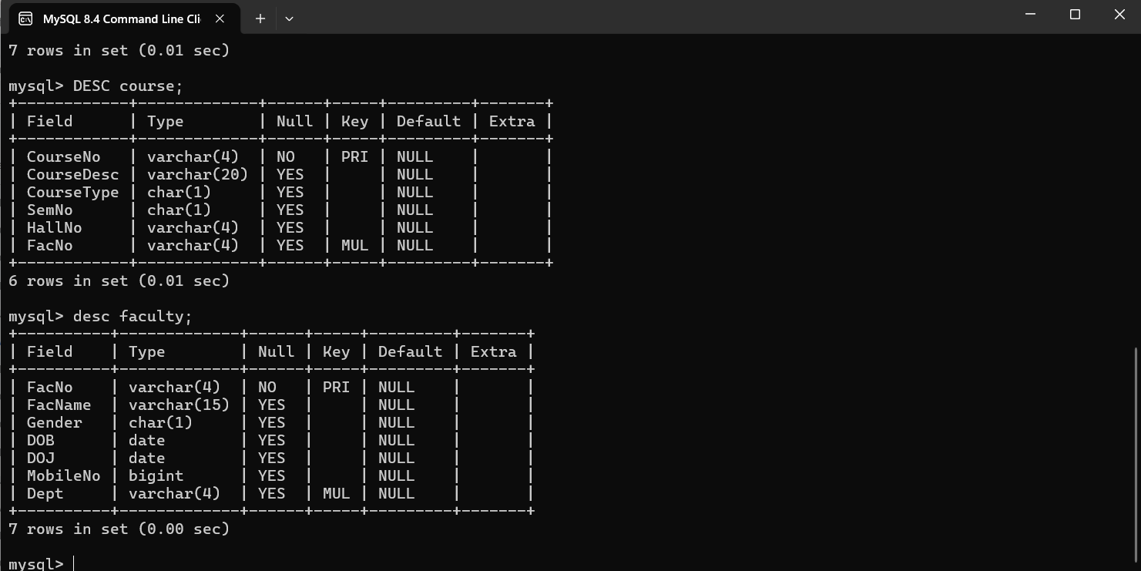

Result
The `FACULTY` table has been created successfully with the required columns and data types.

